

_________________________________________________________________________

**Altizachen** - Second-hand products website - Phase A

**Project Code Number:** 23-1-D-12

**Hadar Iluz:** [Iluzhadar@gmail.com](mailto:Iluzhadar@gmail.com)

**Matan Ben-Hayon:** [Matan012@gmail.com](mailto:Matan012@gmail.com)

**Supervisor: Zeev Brazily**, [zbarzily@braude.ac.il](mailto:zbarzily@braude.ac.il)

**Git:** <https://github.com/IluzHadar/FinalProject-_Phase_A>

**Table Of Contents**

**Abstract** 4

1. Introduction 4

1.1 Organization of the paper 4

1.2 Scope of the project 5

1.3 Project’s stakeholders 5

2. Background and Related Work 5

2.1 Maintaining an ecological environment 5

2.2 Related works 6

2.2.1 **Yad 2** 6

2.2.2 **Facebook Groups** 6

2.2.3 **Bazaars and markets for buying second hand** 6

2.2.4 **Agura** 6

2.3 Agile Development Method 7

2.4 Client-server 7

2.5 Dijkstra’s Algorithm 8

2.6 Cloud computing 10

2.7 Overview of development tools 11

2.7.1 Trello 11

2.7.2 Source Tree-GIT 11

3. Expected Achievements 12

3.1 Goals 12

3.2 Measurable Organizational Value (MOV) 13

3.3 Unique features 13

4. Research / Engineering Process 14

4.1 Process 14

4.2 Product 17

4.3 Software Engineering Documents 17

4.3.1 System Architecture 17

4.3.2 Use case Diagram 18

4.3.3 Class Diagram 20

4.3.3 Activity Diagrams 20

4.4 GUI Design 21

5. Evaluation / Verification Plan 24

5.1 Unit Tests 24

5.2 Functionality testing 25

6. References 26

**Table Of Figures**

Figure - 1 Agile 7

Figure - 2 Client Server 8

Figure - 3 Dijkstra’s Algorithm - PseudoCode 8

Figure - 4 Dijkstra’s Algorithm- step 1 9

Figure - 5 Dijkstra’s Algorithm- step 2 9

Figure - 6 Dijkstra’s Algorithm- step 3 9

Figure - 7 Dijkstra’s Algorithm- step 4 9

Figure - 8 Trello 11

Figure - 9 Source Tree-GIT 12

Figure - 10 Use case diagram 19

Figure - 11 Class diagram 20

Figure - 12 Activity Diagrams 20

Figure - 13 GUI Screens 23

**Tables**

Table - 1 Unit Test 24

Table - 2 Functionality Tests 25

# **Abstract**

The goal of our project idea came with the goal of maintaining an ecological environment and creating a connection between people who are interested in throwing away/donating objects and people with disabilities. The website ‘Altizachen’ enables people to share secondhand products and by that keep our earth. This website serves as a convenient platform for finding a solution for unused second-hand products. People will be able to publish products that they want to throw away, and other people (that search for the same product) will be able to take and so save money. The site displays the ads for each user by sorting ads that are closest to him geographically.

In our website the advertisers will be able to publish ads of the product, take a picture of the product and post the location of the product. The customers will be able to search for a product they are interested in among the various ads that will be published and arrive at the location of the product with a navigation system on our application.   
In addition, the users will be able to post recommendations on the advertiser and on his products and help other users get opinions about the advertiser.

# 1. Introduction

## 1.1 Organization of the paper

1. In part one we explain why we need secondhand products, we explain the benefit of second hand products (protecting our planet).
2. In the second part we describe competing platforms, the technological tools used.
3. In the third part we present the main goals of the project and the measurable organizational values.
4. In this part we define the functionality of the system and the sketch of the final product - the website and the implementation of the functionality through GUI screens.
5. In this part we make unit tests and verification plans of the system that help us to keep the functionality of the system in correctly.
6. The part of references to the sources that were used in writing our project.

## 1.2 Scope of the project

The project is a web application that will contain two main actors: donors, customers.

The flow of the project is initially the distribution of an ad advertising a product by the donor, where the donation is any object in his possession that he wishes to throw away.

The customer, who defines his search radius, will see all the objects available for him in his range and decide if he finds a personal use for them.

The customer will select the object he wishes to take and will contact the donor/advertiser for the collection date. After that the donor and the customer, confirm the collection and decide between them when and where to meet.

At this stage, the donor should have the option to pause the publication of his ad in case the customer regrets and does not come.

## 1.3 Project’s stakeholders

Registered users - people that want to publish ads need to create a new user in the application system. Only registered users can rank other donors, each user will rate by a variety of parameters: amount of ads that they publish and rating from customers.

Anonymous users (customers) - people that are looking for products do not need to register to the application, and they can watch ads, navigate to products and contact the advertisers.

# 2. Background and Related Work

In our globus there are many initiatives in order to protect the environment. One of them is the utilization of second-hand products.

Every object we use, and then throw it away takes years for it to decompose. Therefore, according to articles and studies which have been done on this subject, it is very important to reuse products.

## 2.1 Maintaining an ecological environment

Increasingly, consumers choose ecological products when they do their shopping, not only because it is a healthier option but also because it helps to sustain the environment for future generations.

The article [8] provides an empirical analysis of how consumers' behavior differs based on their level of ecological concern.

They are prepared to switch products for ecological reasons and stop buying products from companies that cause pollution. Finally, the article explores the potential implications of these findings for marketers and others interested in understanding and influencing consumer behavior.

In addition, the article number [9] examines the reasons why people shop second-hand, including financial considerations, environmental concerns, and the desire to find unique items. The article also examines the different types of second-hand stores that consumers visit, and the types of goods that they purchase.

## 2.2 Related works

### 2.2.1 **Yad 2**

The web site ‘Yad2’ helps people sell products they no longer need.   
In this website every user can publish ads for each product (by category), publish photos of the product and with whatever price he wants [4]. Every ad has the phone number of the advertiser, but the user can’t contact them through the site.

### 2.2.2 **Facebook Groups**

On the Facebook social network there are many groups of second-hand products.  
In these groups we can find publications of posts that contain photos and descriptions about the product. In these posts people can make public comments and contact the seller. But the advertisers are not always obliged to present all the details, so many consumers send repeated questions, and many do not receive an answer.

### 2.2.3 **Bazaars and markets for buying second hand**

Almost every city has bazaars and markets that offer different collections at reduced prices and sometimes even display goods for donation. All this is done in order to contribute to those who cannot afford such things themselves.

Usually, a large organization or the municipality itself organizes the collection and distribution. When the main goal is to help those in need along with the possibility of other citizens donating and passing products from hand to hand.

### 2.2.4 **Agora**

The ‘Agora’ website is an online social enterprise that connects people who want to give away things they don't need and people who are looking for them.

The site requires you to hand over at least one item every two months.

A site does not require mandatory fields such as image and details about the product. In addition, only those who are registered on the website can view the details of the advertiser and not necessarily get an opinion on it. Our system manages a user rating that can be viewed by every user and makes sure to post pictures in every ad and other important mandatory fields.

## 2.3 Agile Development Method

In order to find the best development method for us, we researched different methodologies such as: Agile and Waterfall. Our conclusion is that Agile is the most effective development methodology for our project.

The parameters we looked at in choosing the methodology were:

- Minimum time for repair if a requirement changes.

- Developing tasks in small steps.

- Flexibility and response to changes.

In this methodology, the project tasks are broken down into small pieces that come close to execution at the end of work sessions called sprints. Sprints usually last from a few days to a few weeks. Using short work cycles yields flexibility for changes in the middle of the development process as well as at the last moment.

Hence, the use of the Agile methodology will allow us to release an initial version of the system.

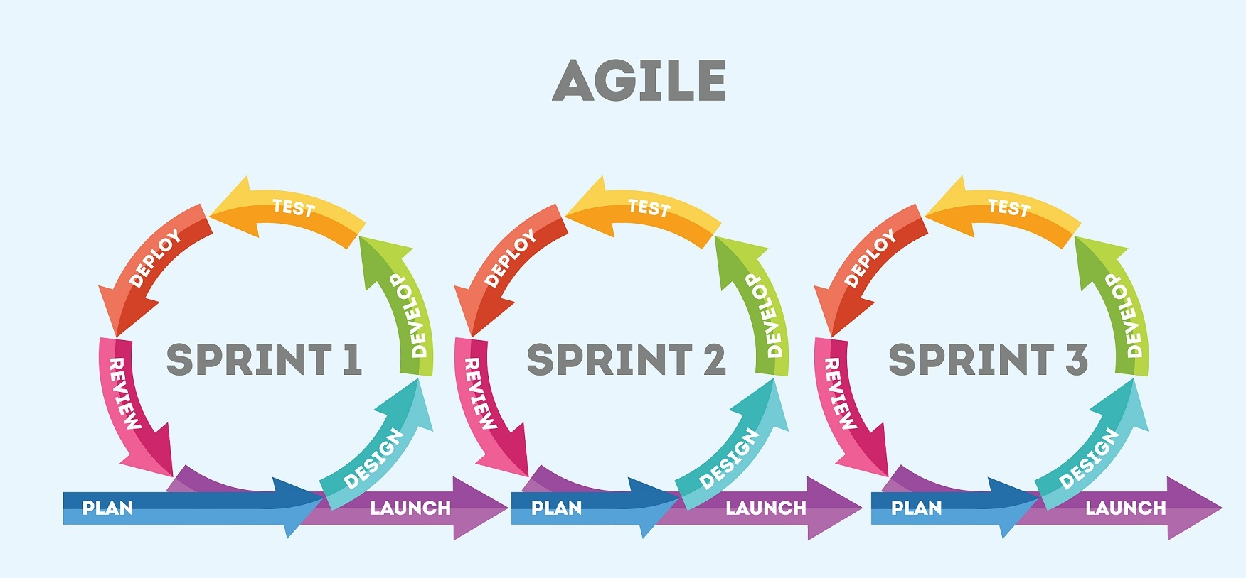

Figure - 1 Agile

## 2.4 Client-server

In order to contact the advertiser and those who are interested in the ads we will use the Client-Server Model. In this model clients initiate requests for services (services like various data unsheathing by queries) and the servers providing service. The client and the servers communicate over a computer network separately.

The client-side is an application that runs on the end-user computer; it provides a user-interface (UI) that handles what the application feels and looks like and how it interacts with the end-user.

The server is responsible for providing implementation of function and contains the logic to send the appropriate data back to the client. The client sends a request to the server to receive information that he found on the data.

The server receives the request and extracts the relevant data and presents it back to the client. In addition, it is also possible to receive a request for the placement of new data to be placed within the server. The communication between the client to server and back is implemented by protocols. The TCP/Ip protocol is the best way to send a tank of data.

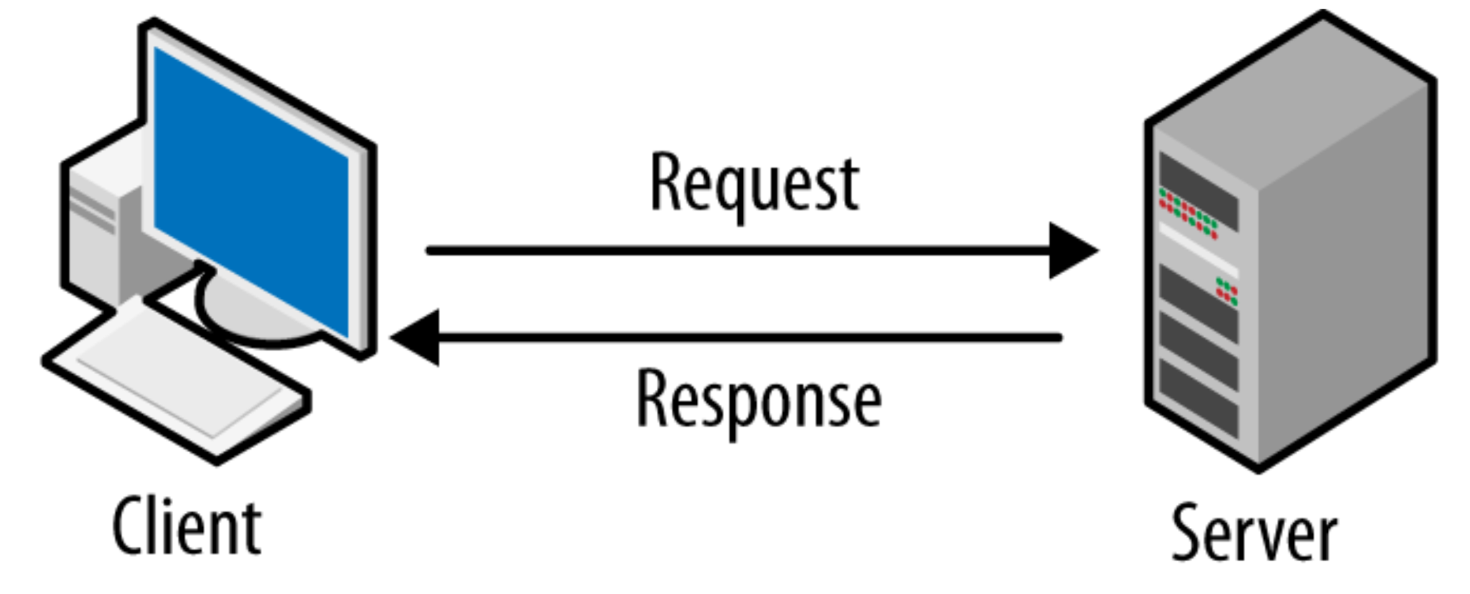

Figure - 2 Client Server

## 2.5 Dijkstra’s Algorithm

In our project we will be using the Dijkstra Algorithm. This algorithm allows us to find the products that are closest to our customer. By that we will be able to best match between the customers and the products. The Dijkstra is a greedy algorithm.

Greedy algorithm is an algorithm that chooses the best step for him out of all the possibilities he has. This approach does not consider the rest of the road and the impact of each step on the continuation of the solution.

How Dijkstra work?  
First, we will turn all the paths into a weighted graph. In order to calculate the shortest path, we will give weight to the edges and the vertices will be a variety of locations. Then we will act according the following order:

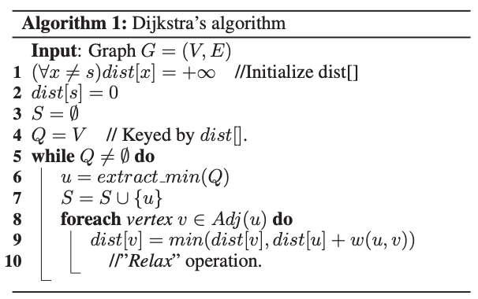

Figure - 3 Dijkstra’s Algorithm - Pseudocode

Example of Dijkstra’s Algorithm:

*reference number [7]*

|  |  |
| --- | --- |
| 1. Initialize distances according to the algorithm | 2. Pick the first node and calculate distances to adjacent nodes. |
| Figure - 4 Dijkstra’s Algorithm- step 1 | Figure - 5 Dijkstra’s Algorithm- step 2 |
| 3. Pick the next node with minimal distance, repeat adjacent node distance calculations. | 4. Final result of shortest-path tree. |
| Figure - 6 Dijkstra’s Algorithm- step 3 | Figure - 7 Dijkstra’s Algorithm- step 4 |

## 2.6 Cloud computing

Cloud computing is a form of computing where data and resources are stored, accessed, and managed over the internet instead of on local servers or personal computers. By using cloud computing, businesses and individuals can store, access, and manage data and applications over the internet. Cloud computing can be used to build websites by providing access to web hosting, server-side scripting, and databases. It can also provide access to platform-as-a-service (PaaS) and software-as-a-service (SaaS) solutions that can be used to create web applications. Cloud computing also makes it possible to quickly scale up or down depending on the website's needs.

In our project, in order to be able to handle such an amount of data storage we will use cloud services. Cloud services are designed to provide easy, affordable access to applications and resources, without the need for internal infrastructure or hardware.

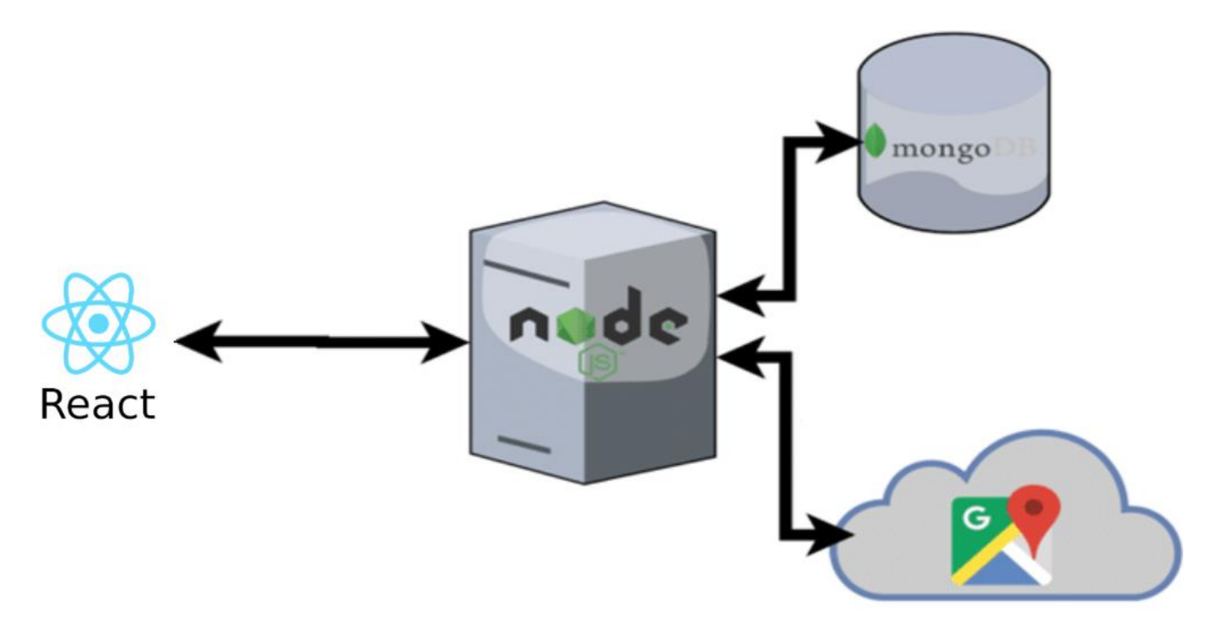

MongoDB is a document-oriented database system that uses JSON-like documents with dynamic schemas, making the integration of data in applications easier and faster. It is an open source, cross-platform database system that can be used with React for building dynamic web applications.

Node.js is an open source, cross-platform, JavaScript runtime environment that executes JavaScript code outside of a web browser. It is used for building fast, scalable network applications. Node.js can be used with React to create powerful web applications with responsive user interfaces.

## 2.7 Overview of development tools

### 2.7.1 Trello

Trello is a collaboration tool that organizes existing projects into boards. In one glance, Trello organizes what's being worked on, who's working on what, and where something is in a process.[1]

A user, like us, can create a template in order to organize his project according to the needs of the project he wants to promote.

We have found that using such a tool helps a couple or more to be in control of their tasks and submissions in a large project, especially when the couple works at different times and needs to synchronize between a project and their personal tasks.

The tool has cards for each week with checklists of everything we, the students, need to do that week including conversations with the supervisor, chapter heads for the book and building UML.

Additional lists with a suggested breakdown of work by week - milestones.

In addition, we can also set goals for the investigation of tools that we want to test if we want to use them in the project and include them in the book. It also helps us to check that there were not too many tasks accumulated in a particular week with the revised schedule.

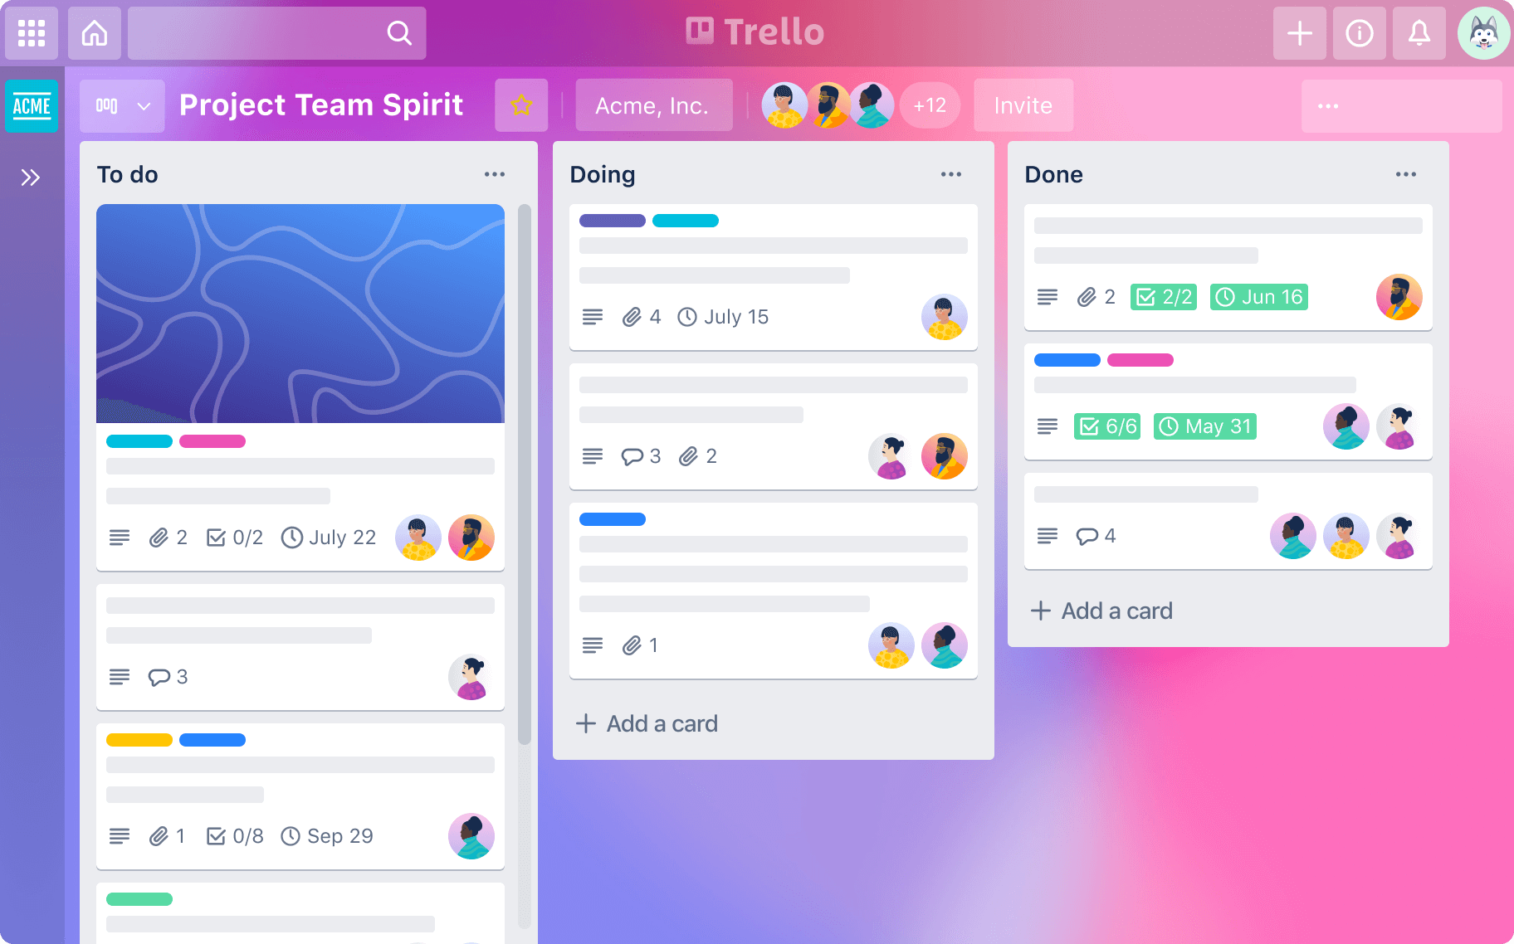

Figure - 8 Trello

### 2.7.2 Source Tree-GIT

SourceTree is a free graphical user interface (GUI) desktop client that simplifies how users interact with Git repositories so that they can fully concentrate on coding.

This GUI makes it easy to visualize and manage different repositories and branch [2].

We were looking for a tool that is used by various companies in the field of software for managing repos in Git so that we can learn a tool that is also useful in the industry.

In addition, as software students, familiarity with Git is very important and this allows you to see the work of all team members in the different branches they are working on.

In addition, important operations such as 'Merge' and resolving conflicts are done with the help of this tool effectively when there is an option for an interface with a feature called beyond Compare, which means that you can see the changes between my branch and the original code found in the main development branch.

In addition, the tool allows you to go back to old commits and see the history in the files with simple graphic symbols.

SourceTree works with Git and takes the project that is on the server and shows us the work environment locally on our computer.

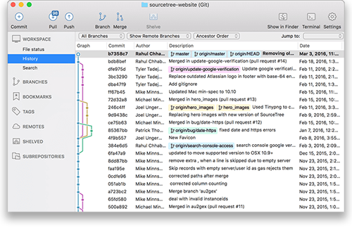

Figure - 9 Source Tree-GIT

# 3. Expected Achievements

## 3.1 Goals

3.1.1 Develop a website that will allow users to post products that they have no use for but someone else can find a lot of use for various reasons.

3.1.1 The system will allow the user to filter ads according to proximity to his residential area.

3.1.3 The system allows you to open a google maps application through the website in order to find the path to the nearest user.

3.1.4 Encourage giving people the option to maintain an ecological environment and consume less.

3.1.5 Create a convenient GUI that is compatible with known platforms in the market so as not to complicate the user.

3.1.6 The site emphasizes all of those parameters that are important to consumers due to our primarily research that we have done, in order to create a reliable community.

## 3.2 Measurable Organizational Value (MOV)

**1.** The construction of the prototype screens will be designed in a simple way that is known from different platforms in the market so as not to complicate the user.

Therefore, the design of the screens will be examined by a focus group that has experience in moving/looking for furniture, that is, a group that has a common feature which is a history of buying second-hand products on different platforms.

Will be performed immediately after the milestone of completing the UML diagrams and will take about a week and a half.

**2.** The distribution of the feature in phase B in the first sprint will be distributed among the partners in a way that there is no dependence on the implementation phases, and this in order to progress in the development task at the same time.

A sprint is defined as two weeks and this MOV refers to the first month.

**3.** See traffic of users logging in to the app and publish at least 5 ads per day from the first month of launching the site.

**4.** The percentage of ads that the system will remove after a specified number of days due to obsolescence will be small compared to the percentage of ads that will be removed from the site following the collection of the product by a customer.

The difference percentage will be at least 60. Within 3 months.

**5.** Within 3 months, 63 presences of our customers will visit our website at least 5 time a week.

**6.** Within 3 months, we will see an increasement in the number of registrants of about 42,000 registrants.

## 3.3 Unique features

1. Locating users by their physical distance and finding the closest route to them.
2. Any user can rate the ad, the more a user who posted an ad with a higher rating, will receive exposure to new ads before everyone else.
3. Each ad will be deleted within X days (which define as 5-6 day max) in order not to overload the servers, in addition to manage the ads in a marketing strategy.
4. To ensure reliability - we will make sure to allow the creation of a user for a single phone number. This will reduce the possibility of opening fictitious users in favor of self-rating for malicious purposes.

# 4. Research / Engineering Process

## 4.1 Process

Many users who advertise a product on Facebook receive thousands of notifications and questions, many of which end up in the spam messages of the user who posted, so there is no answer.

In addition, sometimes the published content lacks details. Our website defines as mandatory fields all the important details that a customer wants to know in order to make an informed decision whether he is interested in the product or not.

First, as part of our preliminary research we wanted to obtain reliable information from our target population. We built a questionnaire that we distributed among people from our work, who are a young population, mostly students, who tend to look for second-hand products among rented apartments.

We chose this target audience in the initial phase because it was the most accessible for us and we could get fast and reliable feedback from it. In addition, we had the option to contact them with additional questions to get a detailed description easily.

After minor corrections that emerged from the group of critics, we started sending the final questionnaire in groups on Facebook and asking people to answer the questionnaire and thus collect information about how our site helps them and what helpful patches/ what bothers them with the currently existing method/ how much they think it will advance the goals, etc.

Link- <https://forms.gle/qD7bgQPAdVg7Y5hb6>

|  |  |  |
| --- | --- | --- |
| 1 | 2 | 3 |
| 4 | 5 |  |

**Analysis of the answers that emerged from the questionnaire:**

After a reasonable period of about two and a half weeks, we performed an analysis of the answers that emerged from the answers to the questionnaire.

First, it was possible to conclude from the first 2 questions that almost most of the people reported that they would like to help protect the environment and change the consumption culture, but in practice they do not do it.

From the third question it can be concluded that many people tend to consume second-hand products in second-hand stores and Facebook groups and then use the YAD2 website.

From the fourth question you can clearly see that the thing that is most important to consumers and will help them the most is posting a picture and location of the product.

The next question was an open question, we received less answers because we didn't want to limit it to being a mandatory question. We wanted to reduce the chance that people who start answering the survey will stop, to prevent a situation where they would notice that they must type text and due that eventually will not submit the questionnaire.

Despite everything, the answers that were repeated the most were product placement and image.

In the last question, most of the people rank 5, which is the high effect, thereby indicating that presenting products that are closer to him geographically will significantly increase the chance that he will want to consume second-hand products.

Second, as part of our preliminary research, we wanted to understand the alternative solutions that exist today in the market, understand their advantages and disadvantages and how we can improve and at the same time preserve what works well to provide unique ideas for our system.

Therefore, we found that building a website would maximize the match according to criteria we collected from the questionnaires and would be an ideal platform that would connect the publisher and the customer.

In this way we save valuable time for both parties in searching and locating products near him.

In addition, we also researched the technology we chose to use.

In order for the advertiser and the client to establish contact with each other, we will use a server that is connected to a database of all the ads, advertisers, etc.

All clients will be connected to the Google Maps API.

As part of the process in the agile working method we chose, we scheduled weekly meetings in which we detailed and wrote down the functional and non-functional requirements of the system. This helped us a lot to design the UML diagrams whose role is to illustrate what the system is capable of doing and what actions each player can perform in it.

We emphasize that these charts may change in the future, but they are the basis from which we will start working in the coding stages.

## 4.2 Product

‘Altizachen’ is a website for sharing second hand products. The site displays the ads for each user by sorting ads that are closest to him geographically. In addition, the system allows users to rate advertisers and thus we try to create a safe and reliable space of high-quality and preserved products that can be transferred. Our system is responsible for coordinating the shortest path between the users, therefore, to achieve the shortest route, we would like to use a greedy algorithm. At each of its steps, it will choose the shortest option Thus it will achieve the shortest route.

This algorithm is called: Dijkstra's algorithm. The algorithm was created and published by Dr. Edsger W. Dijkstra, a brilliant Dutch computer scientist, and software engineer. In 1959, he published a 3-page article titled "A note on two problems in connection with graphs" where he explained his new algorithm. [5].

## 4.3 Software Engineering Documents

### 4.3.1 System Architecture

In order to create our system architecture, we want to look at 3 main aspects:

Identifying the problem and conducting research -

identify an environmental need by questionnaires, collect information about the stakeholders, and market characteristics.

We understand that people don't want to waste their time finding someone who is interested in their products. Therefore, for the rabbi, the most convenient solution for them is to simply get rid of the product and throw it away. Most of the respondents answered that they were interested in donating and passing it on, but the most important emphasis for them is that the action be done in the fastest and simplest way.

Create a stable basis for solving the problem-

The result of this step is to define the main objectives that our system must meet, so that it can overcome the solutions found in the market today. In addition to implementing the minimum needs of both parties so that the communication between them is optimal and ideal for both parties. Therefore, in this aspect we define what the functional requirements of the system are, define a number of criteria that will connect the advertiser and the client by A simple and clear user interface that will allow users to experience donating second-hand products and saving the environment effortlessly quickly and efficiently, in this way, we make the user experience comfortable, fast and save him valuable time.

Implementation - The purpose of the Implement phase is to create a plan for developing a concept into a real development that is effective for users and attractive to providers. The focus of this phase A is on developing and integrating core strategies for our project and UMLs diagrams. These diagrams might be changed in the future, but they will be our base.

### 4.3.2 Use case Diagram

The system has 3 types of actors:

General user:

* The system allows create a new subscribe user by sign in action.

Customer (unsubscribe user):

* The system allows view products according to the user`s location.
* The system allows the user to view the ad and its details.
* The system allows writing a comment on another advertiser(donor).
* The system allows users to mark ‘like’ on an ad.
* The system allows the user to locate the product’s location through the Google Maps application.
* All the functions of a customer user are inherited to the registered user(donor).

Donor user (subscribe):

* The system allows registered users to create a new ad.
* When creating a new ad, the user must enter an image of the product, it`s location and more information on the product.
* The user will be able to edit ads that he has posted.
* The system will allow the user to view his personal details in the personal area and edit them.
* The system allows change ad status (Pause/active/close)
* The system allows users to rate other donors.
* The system allows the user to view his rating in his ‘personal area’ page.
* The system will allow to classified ads according to different categories at the creation of an ad.
* The system checks donor statistics and ranks donors as VIP.
* The system displays ads for VIP-ranked donors before other users.

Admin user:

* The system allows admin user to delete ads.
* The system allows admin user to delete registered users.
* The system allows the admin user to view statistics on the various donors.

for guests, no need to register and log in, they can search and see existing ads.

- Login: The system allows registered users to enter their email and password to log in.

- Sign Up: The system allows fill registration form, gust will need to enter

the following details: username, email(twice), password(twice), full

name and phone number.

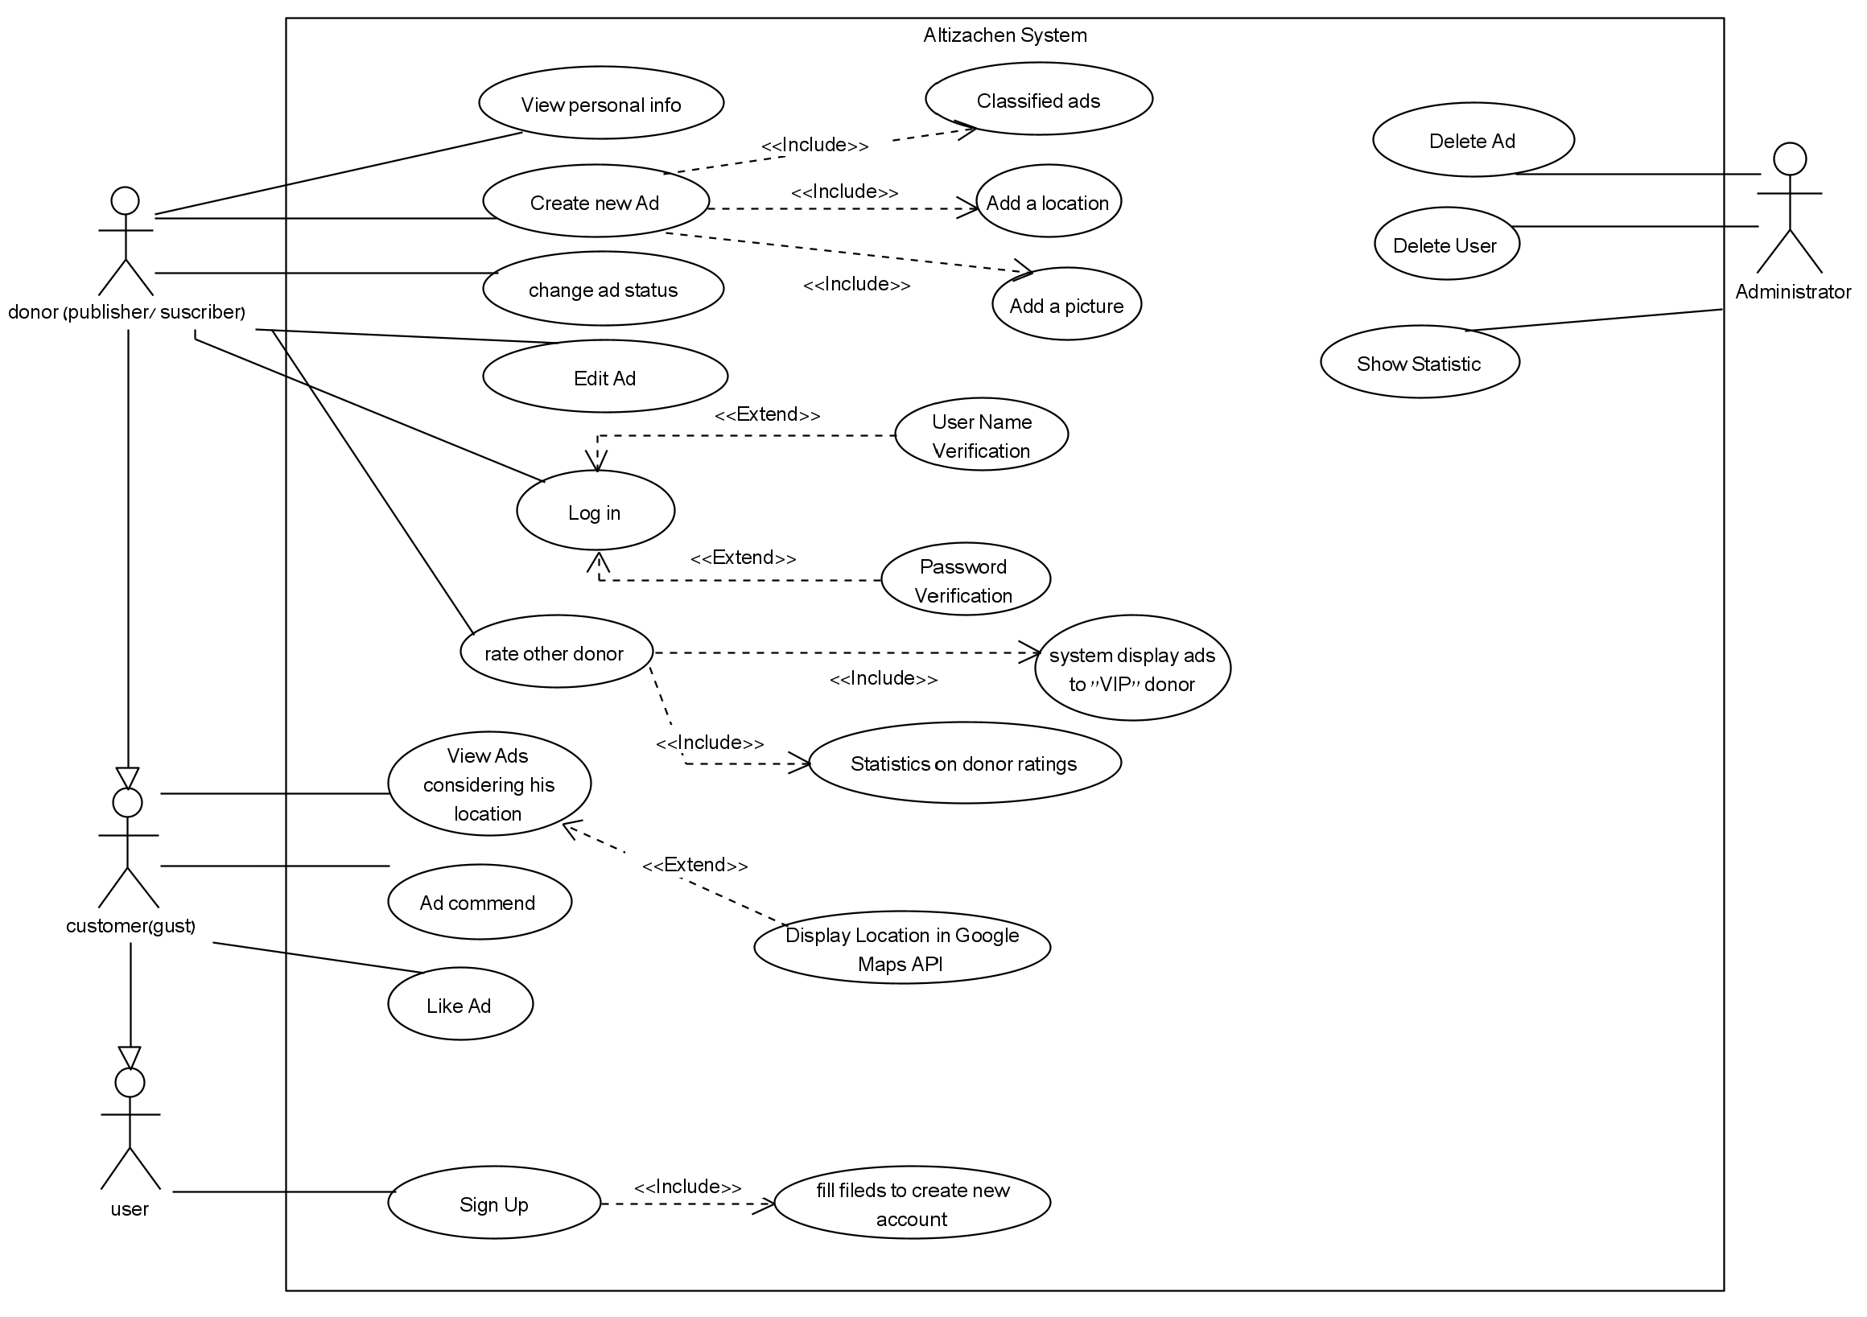

Figure - 10 Use case diagram

### 4.3.3 Class Diagram

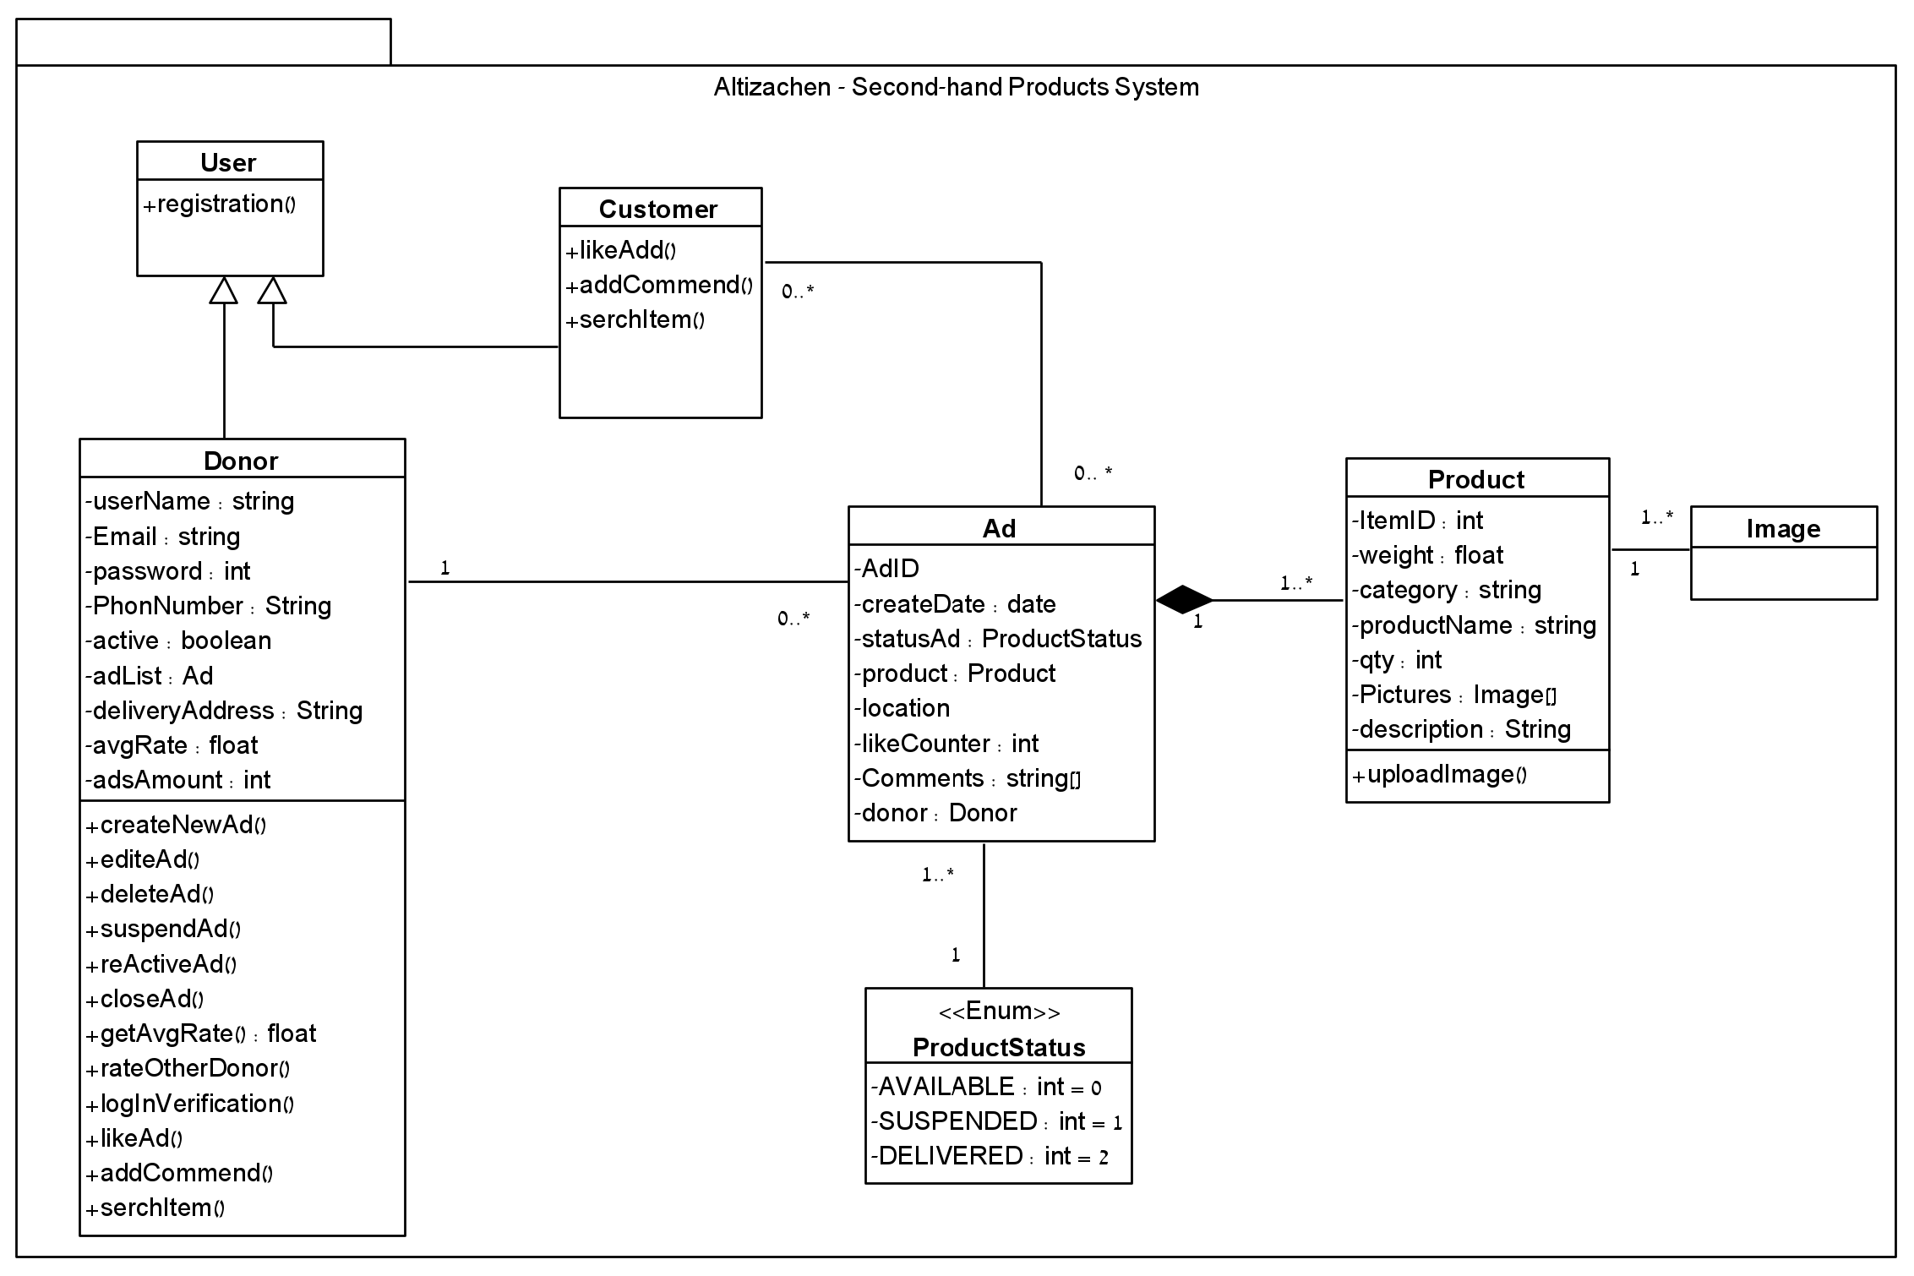

Figure - 11 Class diagram

### 4.3.3 Activity Diagrams

**create new ad:**

|  |
| --- |
| Figure - 12 Activity Diagrams |

## 4.4 GUI Design

|  |
| --- |
|  |
|  |
|  |
|  |
| Figure - 13 GUI Screens |

# 5. Evaluation / Verification Plan

In order to test and evaluate our system, we selected to perform two types of tests:

1. Unit testing - Testing individual modules.

2. Functionality testing - Testing the functionality as per user requirements.

## 5.1 Unit Tests

| # | Subject | Test Name | Test Plan | Expected Result |
| --- | --- | --- | --- | --- |
| 1 | Add New Product | Unsuccessfully create new ad. | Adding a new ad without an image. | Failed to create new ad. |
| 2 | Unsuccessfully create new ad. | Adding a new ad without selecting a category | Failed to create new ad. |
| 3 | Registration | Unsuccessfully Sign In | 1. set password in the first field.  2. set not matching password in the second field. | The message “Passwords do not match, please retype" display on the screen. |
| 4 | Sign In | 1. verify that all required fields are empty. | The message: "Please fill all required fields" displayed on the screen. |
| 5 | Successfully Login | 1. set valid email.  2. set a valid password.  3. click on the “sign In” button. | The user enters the site successfully and his details are displayed at the top of the site. |
|  | Rate donor | Successfully Self-rating | Log in as a registered user and rate yourself. | Self-rating failure. |

Table - 1 Unit Test

## 5.2 Functionality testing

| # | Test Plan | Expected Result |
| --- | --- | --- |
| 1 | Enter correct Login details and press on the Login button. | The screen switches from login page to home page. the user details display at the top of the site. |
| 2 | Unsuccessfully create a new ad:  Users can not create a new ad without a picture.  1. upload an image.  2. fill all the required field.  3. write a description of the product.  4. delete an image.  5. post Ad. | The message “An ad cannot be published without a picture of the product, please add a picture.” display on the screen. |
| 3 | Successfully create a new ad:  1. upload an image.  2. fill all the required field.  2. write a description of the product.  4. post ad | The message “New ad has been posted” displays on the screen. |
| 4 | 1. Click on the "Edit ad" button.  2. Select "suspend" status for Status field  3. Click the “save” button.  4. search this ad in the home screen. | Verify ads are **not** displayed on the main home screen. |
| 5 | Add new review: click on ad and add new command, click send. | Verify the new command display below the ad details. |
| 6 | Rate a donor:  Preliminary step - create a new user in the system by signing in and publish a new ad successfully.  1. enter to this donor details from another user.  2. pick a rate of 5/5.  3. repeat step 1 from 3 different users on the same donor from the preliminary step. | The rating of the ad is displayed on the ad.  The user's rating has increased accordingly. |
| 7 | 1. Enter the site through a registered user.  2. Click on the "view my ads" button. | Verify that all the messages that the user opened are displayed and drawn to him. |
| 8 | 1. Enter the register page.  2. Enter address email without prefix before the ‘@’.(include ‘@’)  3. Click on “register” button. | Show an error message, in red color on the same page: “Address email invalid”. |

Table - 2 Functionality Tests

# 6. References

[1]. Trello usage- <https://support.atlassian.com/trello/docs/what-is-trello/>

[2]. SourceTree - <https://www.globallogic.com/services/offerings/atlassian/sourcetree/>

[3]. Agile Method- Cammin, P., Heilig, L., & Voß, S. (2021). Assessing requirements for agile enterprise architecture management: A multiple-case study.‏

[4]. Yad2 - website and application for selling products, tickets and more.

<http://www.yad2.co.il>

[5].Dijkstra's algorithm, Wikipedia- <https://en.wikipedia.org/wiki/Dijkstra%27s_algorithm>

[6].Dijkstra's algorithm, - geeksforgeeks <https://www.geeksforgeeks.org/dijkstras-shortest-path-algorithm-greedy-algo-7/>

[7].Dijkstra's algorithm example - <https://samanbatool08.medium.com/dijkstras-shortest-path-algorithm-ff723056b608>

[8]. Fraj, E., & Martinez, E. (2007). Ecological consumer behavior: an empirical analysis. International journal of consumer studies, 31(1), 26-33.

[9]. Haraldsson, F., & Peric, S. (2017). Drivers and motivations for second-hand shopping: A study of second-hand consumers